HR Data Analysis and Visualization

Project Description:
This Power BI assessment focuses on importing, cleaning, analyzing, and visualizing HR data to derive actionable insights. Through various analytical functions and visually appealing charts, we aim to uncover insights that aid decision-making within the organization.

Session Objectives:
After completing this session, participants will be proficient in:
- Importing HR data for analysis.
- Cleaning and preparing data for analysis.
- Conducting data analysis using various analytical functions.
- Visualizing findings through visually attractive charts.

Project Scope:
The organization seeks to utilize HR data to address the following objectives:
1. Cost Center Analysis: Record details of each cost center, including available leaves, average salary, total salary cost, and yearly average tenure to understand cost utilization across all centers.
2. Budget Preparation: Analyze total cost, number of employees, average tenure, and leave balance for each cost center to efficiently prepare budgets.
3. Employee Status Analysis: Determine the number of active and inactive employees within business units to identify retention strategies.
4. Age Group Analysis: Evaluate the total number of employees across different age groups to assess performance and align skills with tasks accordingly.

Project Steps:
1. Importing Data: Import HR data into Power BI for analysis.
2. Data Cleaning: Clean and prepare the data for analysis, ensuring accuracy and consistency.
3. Data Analysis: Utilize various analytical functions to derive insights related to cost centers, budget preparation, employee status, and age groups.
4. Visualization: Visualize findings using visually appealing charts to present insights effectively.

Dashboards:
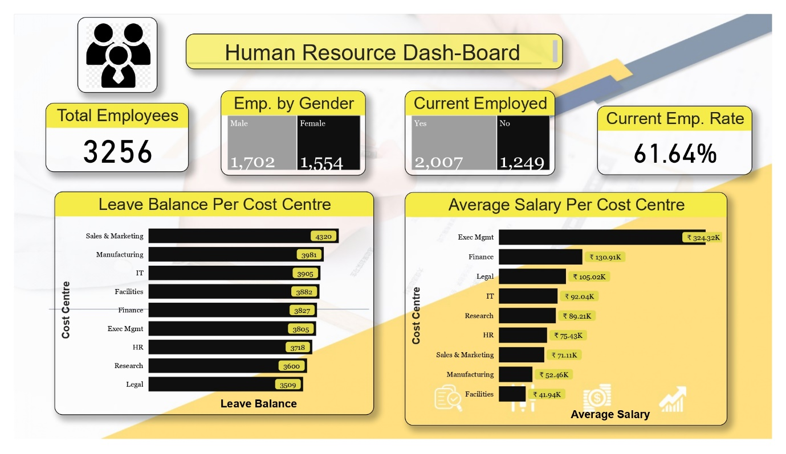

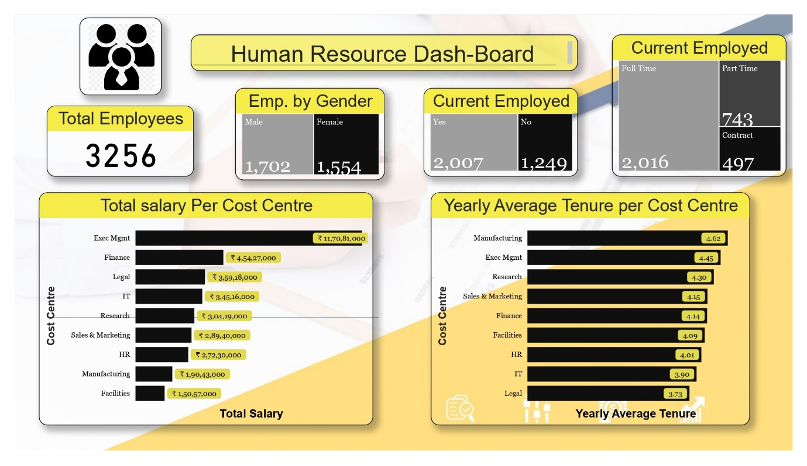

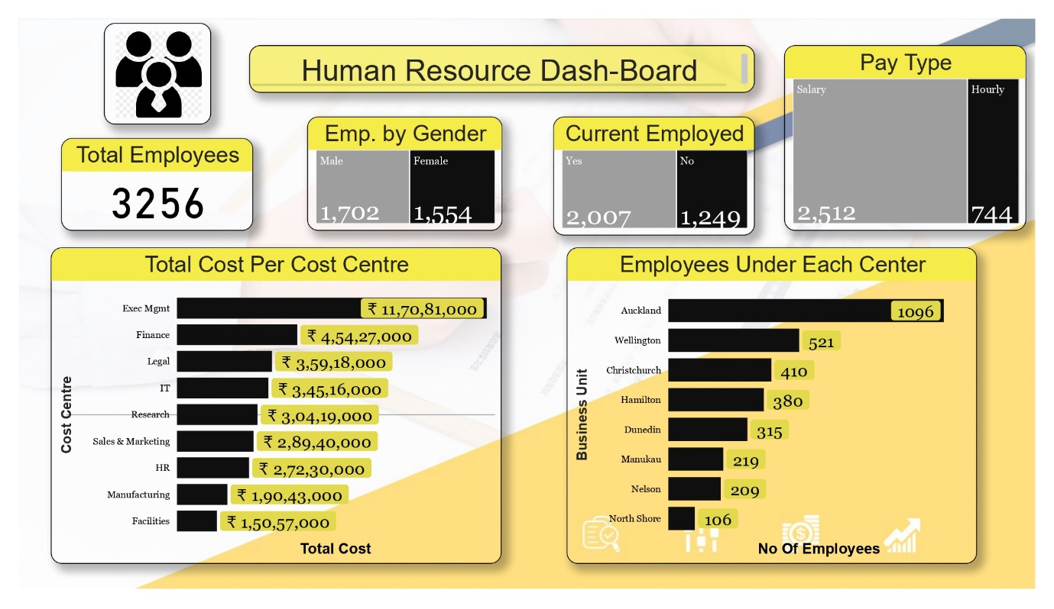

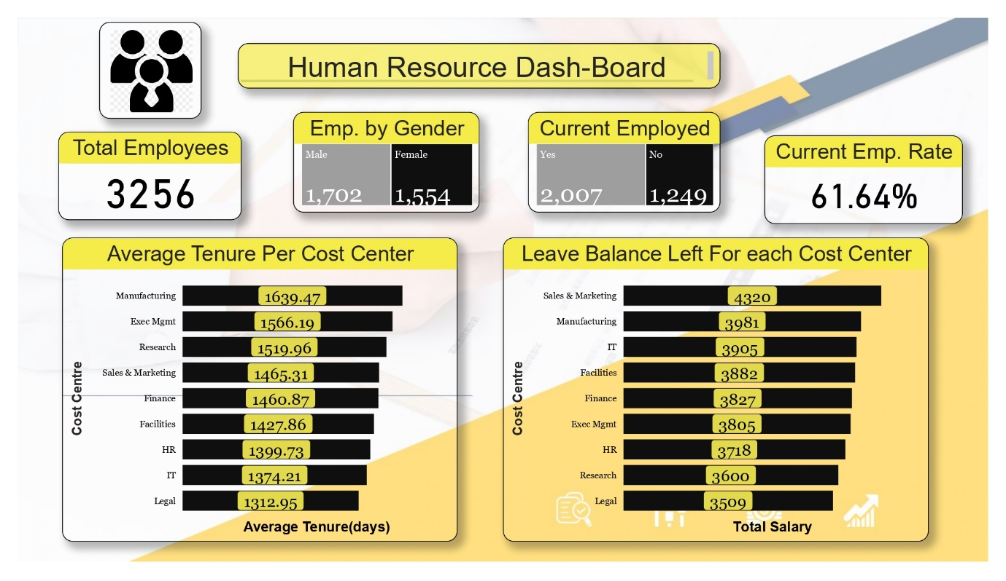

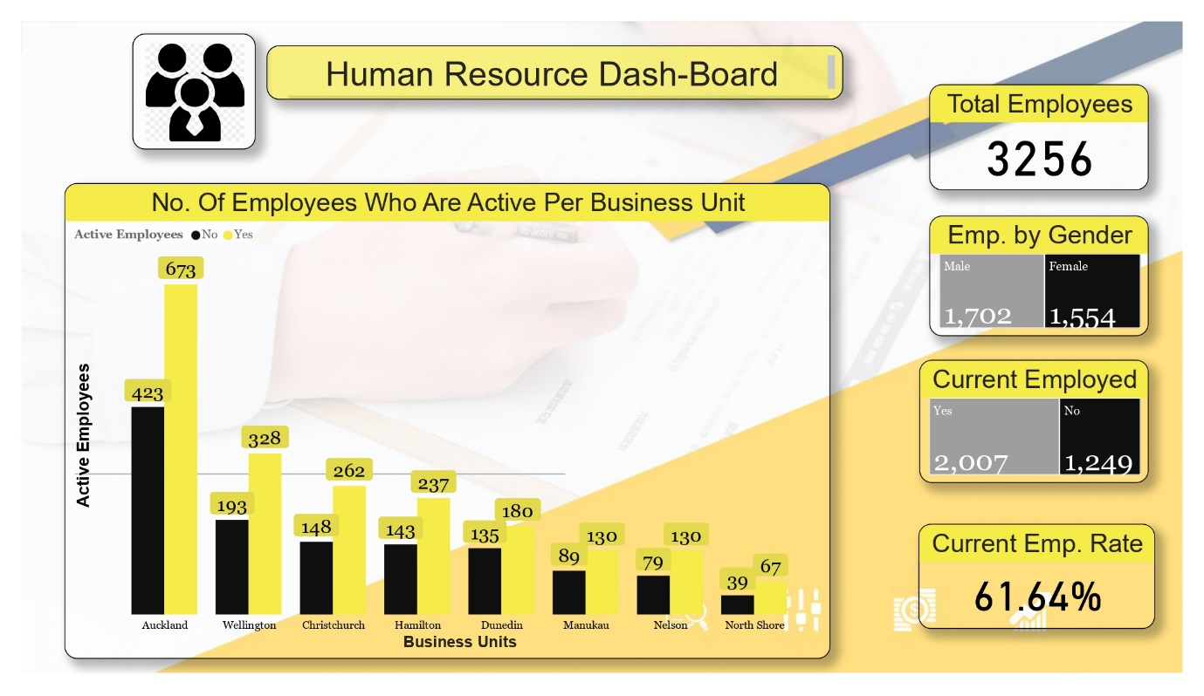

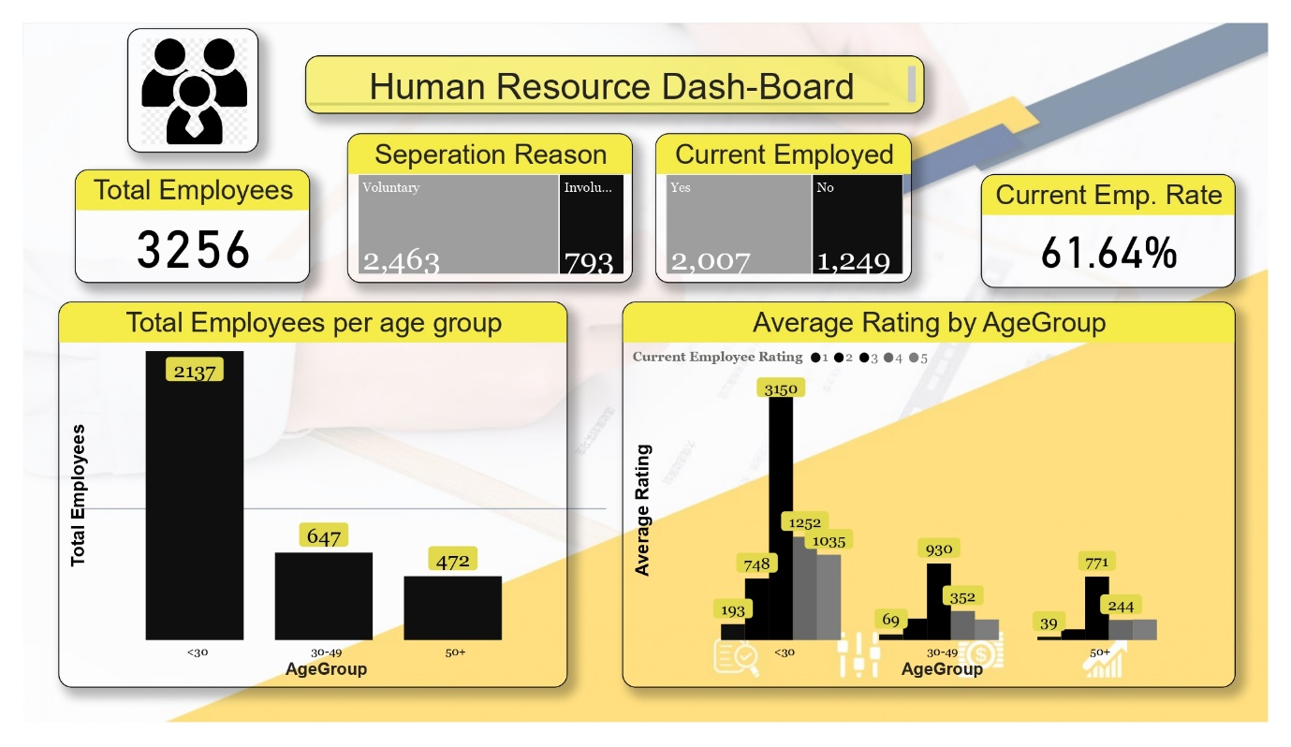

Key Deliverables:
- Detailed analysis of cost centers, including leaves, salary costs, and tenure.
- Efficient budget preparation for each cost center based on analyzed data.
- Identification of active and inactive employees within business units for targeted retention strategies.
- Assessment of employee performance across age groups for skill alignment.

Conclusion:
By leveraging Power BI for HR data analysis and visualization, the organization can make informed decisions regarding cost utilization, budget allocation, employee retention, and skill alignment. This assessment equips participants with the skills needed to transform raw HR data into actionable insights, driving organizational success.

